The Book of Mormon in a Nutshell:
A man named Mormon tells his son, Moroni (a Nephite), to bury the record of their people in the ground, in New York State around 421 A.D., to protect this record (the plates) during a war they were losing to the Jewish Native Americans (Lamanites). Centuries later, the angel Moroni appears to Joseph Smith in a vision and tells Joseph that he recorded the events of his people on golden plates and where he buried these plates. Joseph Smith then finds and “translates” the plates which together are the supposed Book of Mormon.
Archaeology
The Book of Mormon mentions swords, arrow heads, darts, javelins, and even tools all made of steel, iron, copper and brass (Jarom 1:8), yet there has never been one of these found. Same with coins. The Book of Mormon mentions minting several different coins (Alma 11:4-19), yet no one has ever found even one. The archaeological record is completely missing! This is not the case with the Bible.
None of the names of the locations and cities are the same in New York as they are in the Book of Mormon, but one today can still visit Jerusalem, the City of David, Athens, Rome, and Corinth, which are all mentioned and described in the Bible.

DNA
The Book of Mormon teaches that Native Americans are actually Jewish, but evidence from DNA testing (as well as anthropological studies) reveals that Native Americans are descendants of a people who migrated from Asia.
The Church of Jesus Christ of the Latter-Day Saints teaches that a man can become a God and populate his own planet:

“As man now is, God once was: As God now is, man may become.”
~Fifth Mormon President, Lorenzo Snow
But what does the Bible claim about God?
“Before me no God was formed, nor will there be any after me” (Isaiah 43:10).
“God is not human, that he should lie, not a human being, that he should change his mind” (Numbers 23:19).
“For I am God, and not a man-- the Holy One among you” (Hosea 11:9).
“I the LORD do not change” (Malachi 3:6).
“Is there any God besides me? No, there is no other Rock; I know not one” (Isaiah 44:8).
These verses show that our eternal God was never a man and that there is no other God. If there ever was another God, it seems that out of anyone, He would know of Him.
Clear Contradictions

The Bible: Ephesians 2:8-9 says, “For it is by grace you have been saved, through faith—and this is not from yourselves, it is the gift of God—not by works, so that no one can boast.”

The Book of Mormon: 2 Nephi 25:23 says, “For it is by grace that you are saved, after all you can do.” Mormonism teaches that Jesus cleans up what you cannot do. You are partially earning your way to heaven.
The B.I.T.E. Model:

Behavior Control: Cults across the board require that their members are under controlled behavior. They are told that they are to act, dress, and behave in a certain way. They promote dependence on the Latter-day Saint material. Mormons believe that “the Book of Mormon is the most correct of any book on this earth,” including the Bible.

Information Control: Mormons are told to stick to their own material because only their organization has the truth. Cults make the claim that they are the only truth. Christianity is not like this. Anyone who is anything from Catholic to Pentecostal can be saved. They are told to read material only from their own sources because they are told that only the Mormons are capable of knowing the whole truth.

Thought Control: Mormons are pushed to study only with other members and not with anyone else. They teach their members that evangelical Christians do not have as many sacred books, so they must be of less value, of less stature; greatness.

Emotion Control: There is no hope for you beyond their organization. They will help you a lot when trying to convert you (love bombing), but when you threaten to leave because it is wrong or strange, they will tell you that you will no longer receive help (excommunication) and you will die. They control you by your fear that they carefully and slowly create.

Source: freedomofmind.com/bite-model

Good questions to ask Mormons:
Why is the Book of Mormon written in King James Version language when no one spoke like that at the time it was translated?
How is Jesus a created being if Hebrews 13:8, and John 1:1-3 (et. al.) say that He is always the same and has always existed?
How do you explain the DNA of Lamanites?
Where is the archaeological record? Why does the entire world not recognize the Book of Mormon as an accurate archaeological record, but archaeologists use the Bible to research locations, geography, and even relics? Stick to the subject. Don’t let them jump around or change the subject.

The Book of Abraham is one of the sacred canonized texts of Mormonism which came to exist supposedly translated through an Egyptian papyrus that Joseph Smith bought from a traveling antiquities vendor. It was believed that the papyrus was lost in the Great Chicago Fire, but the Metropolitan Museum of Art had it in their archives and so the Egyptologists translated it and discovered that it was instead directions for Egyptians to embalm the dead.

Definitions: Mormons call themselves “Christians,” but this is wrong because they do not follow the biblical Jesus. When they talk about Jesus, they are talking about a different Jesus than who is found in the Bible. Watch for words that have different meanings, such as Jesus, Christian, and even Bible.
(See Galatians 1:6-9.)

The Moroni Challenge: Mormons will say that when you read the Book of Mormon, you should pray and ask God if it is true and that if you ask with a sincere heart, then God, through the power of the Holy Ghost will prove to you in your heart that it is true. If it is our hearts alone knowing that it is the truth, then how does a Muslim not know that the Quran is true?
(See Jeremiah 17:9.)

Revelation 22:18-19 tells its readers that anyone who adds to the prophecies of this book will be cursed, which is what the book of Mormon does. Mormons will try to show you Deuteronomy 4:2 which is a commandment not to add or subtract from the commandments, yet there are many further commandments in the Bible, but they are wrong. These also discuss two different subjects: commandments and prophecy.

For Further Study:
Fast Facts on False Teachings, by Carlson and Decker.
Kingdom of the Cults, by Walter Martin.
Sharing the Good News with Mormons, by Johnson and McDowell
Unveiling Grace, by Lynn Wilder
For more information and material, visit:
https://apologeticsandevidence.blogspot.com/

www.facebook.com/ApologeticsAndEvidence/

(Permission is granted to make copies of this pamphlet and to distribute them, provided this is done free of Charge and without altering the content.)

Defending Christianity Against Mormons

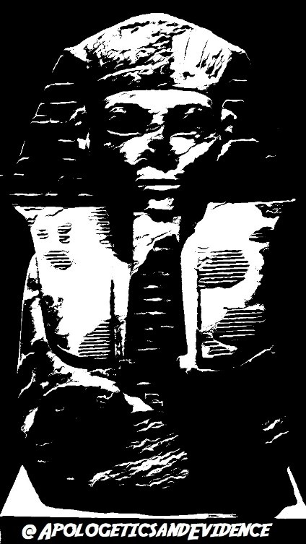

“Contend for the faith that was once
for all delivered to the saints.”
~Jude 3

